**2014 Honda Accord E-Stop Info**

**For emergency use only:**

**Longitudinal controller failure / runaway acceleration**

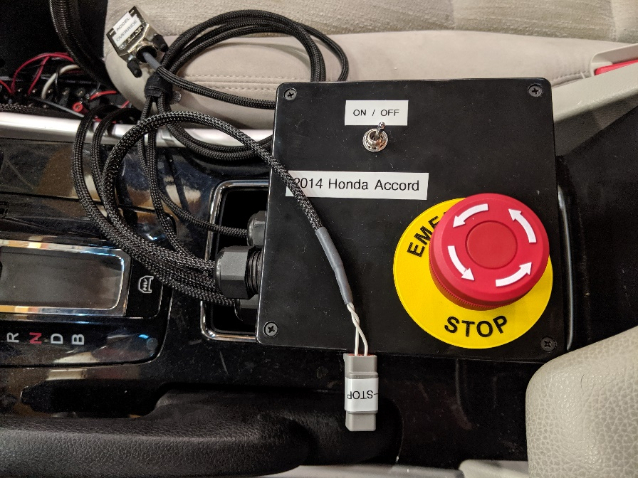

* E-Stop Disables:
  + Stock accelerator pedal operation
  + Accelerator pedal override
  + Panda man-in-the-middle override of braking
* E-Stop operation will render the stock accelerator pedal unresponsive and cause vehicle faults to occur. E-Stop needs to be released and a vehicle key cycle performed to return accelerator pedal operation back to normal.
* Extra “E-Stop” connector can be used to switch off other equipment at the same time
  + Creates open circuit between the two pins of the “E-Stop” connector when pressed
* The ON/OFF switch should be used to enable/disable pedal override control during normal operation
  + This allows continuous normal operation of stock accelerator pedal